EXPERIMENT 6
Text Generation using OpenAI LLM API
Name | P Nishanth
Register Number | 192472292

AIM
To demonstrate text generation for a given prompt using an OpenAI-style LLM task.

PROCEDURE
- Open Python IDLE, VS Code, PyCharm, or Google Colab.
- Display a predefined prompt about Artificial Intelligence.
- Prepare a sample generated response for the prompt.
- Display the prompt and the generated text.
- Run the program and observe the output.

PROGRAM
print("Text Generation using OpenAI LLM API")

prompt = "Explain Artificial Intelligence" print("\nPrompt:", prompt)

generated_text = """
Artificial Intelligence (AI) is a branch of computer science that enables machines to perform tasks that normally require human intelligence.
"""

print("\nGenerated Text:") print(generated_text)

OUTPUT
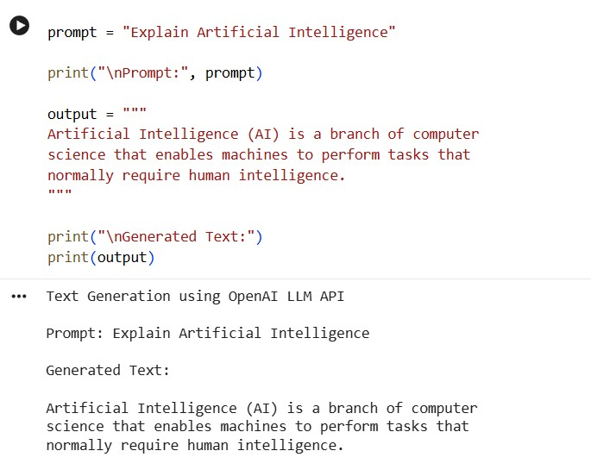

RESULT
Thus, the program demonstrating text generation using an OpenAI-style prompt was executed successfully.

